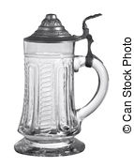
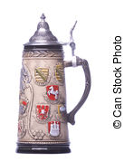
German!
FALL 2017 LOWER DIVISION CLASSES
LGER100 First Year German I 5 credits
001 78582 10-10:50 MWF; Online TR F. Wilcox 102 Eddy
002 78646 11-12:50 MWF; Online TR TBD 102 Eddy
003 78584 12-12:50 MWF; Online TR F. Wilcox 103 Eddy

LGER101 First Year German II 5 credits
001 78586 1-1:50 MWF; Online TR F. Wilcox 123 MRBSC

LGER200 Second Year German I 3 credits
001 73743 1-1:50 MWF R. Kirby C360 Clark

LGER201 Second Year German II 3 credits
001 62543 2-2:50 MWF TBD 103 Eddy
For more information, contact: Languages, Literatures & Cultures Dept., C104 Clark, 970 491-6141, Carol.Hughes@Colostate.edu

German!
FALL 2017 LOWER DIVISION CLASSES
LGER100 First Year German I 5 credits
001 78582 10-10:50 MWF; Online TR F. Wilcox 102 Eddy
002 78646 11-12:50 MWF; Online TR TBD 102 Eddy
003 78584 12-12:50 MWF; Online TR F. Wilcox 103 Eddy

LGER101 First Year German II 5 credits
001 78586 1-1:50 MWF; Online TR F. Wilcox 123 MRBSC

LGER200 Second Year German I 3 credits
001 73743 1-1:50 MWF R. Kirby C360 Clark

LGER201 Second Year German II 3 credits
001 62543 2-2:50 MWF TBD 103 Eddy
For more information, contact: Languages, Literatures & Cultures Dept., C104 Clark, 970 491-6141, Carol.Hughes@Colostate.edu

